**ZOMATO**

**WEB APPLICATION**

**Zomato is a restaurant aggregator and food-delivery start-up. It provides information, menus and user-reviews of restaurants, and also has food delivery options from partner restaurants in select cities.**

**1.After opening the zomato website we can login or sign up to further access the applications of it.**

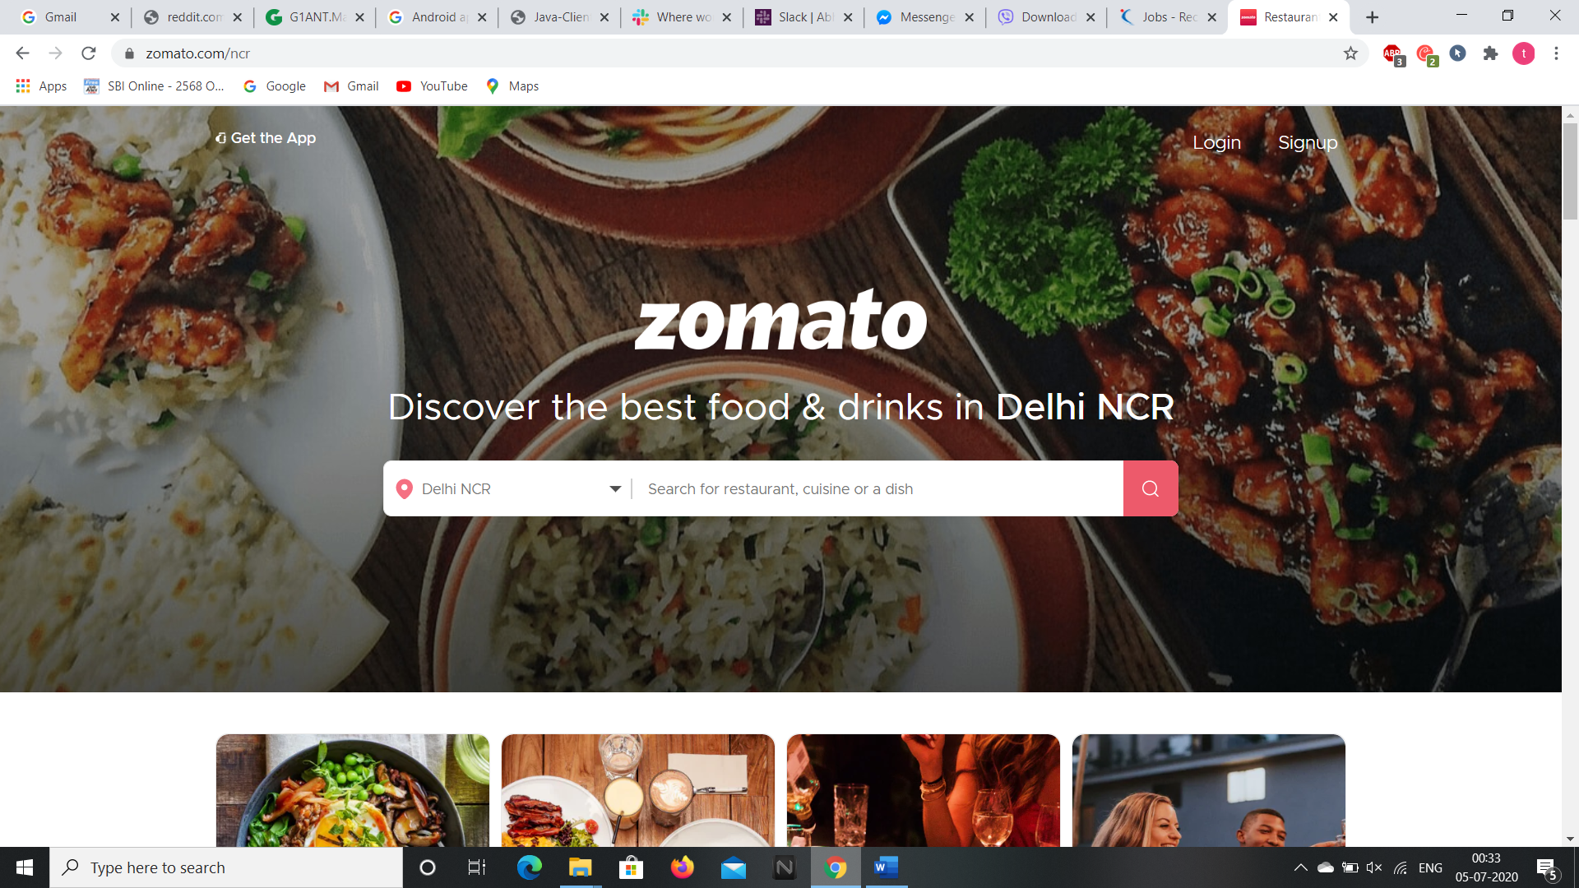

**2.After logging in, the home page is opened with the popular collections and localities near your area by giving the location.**

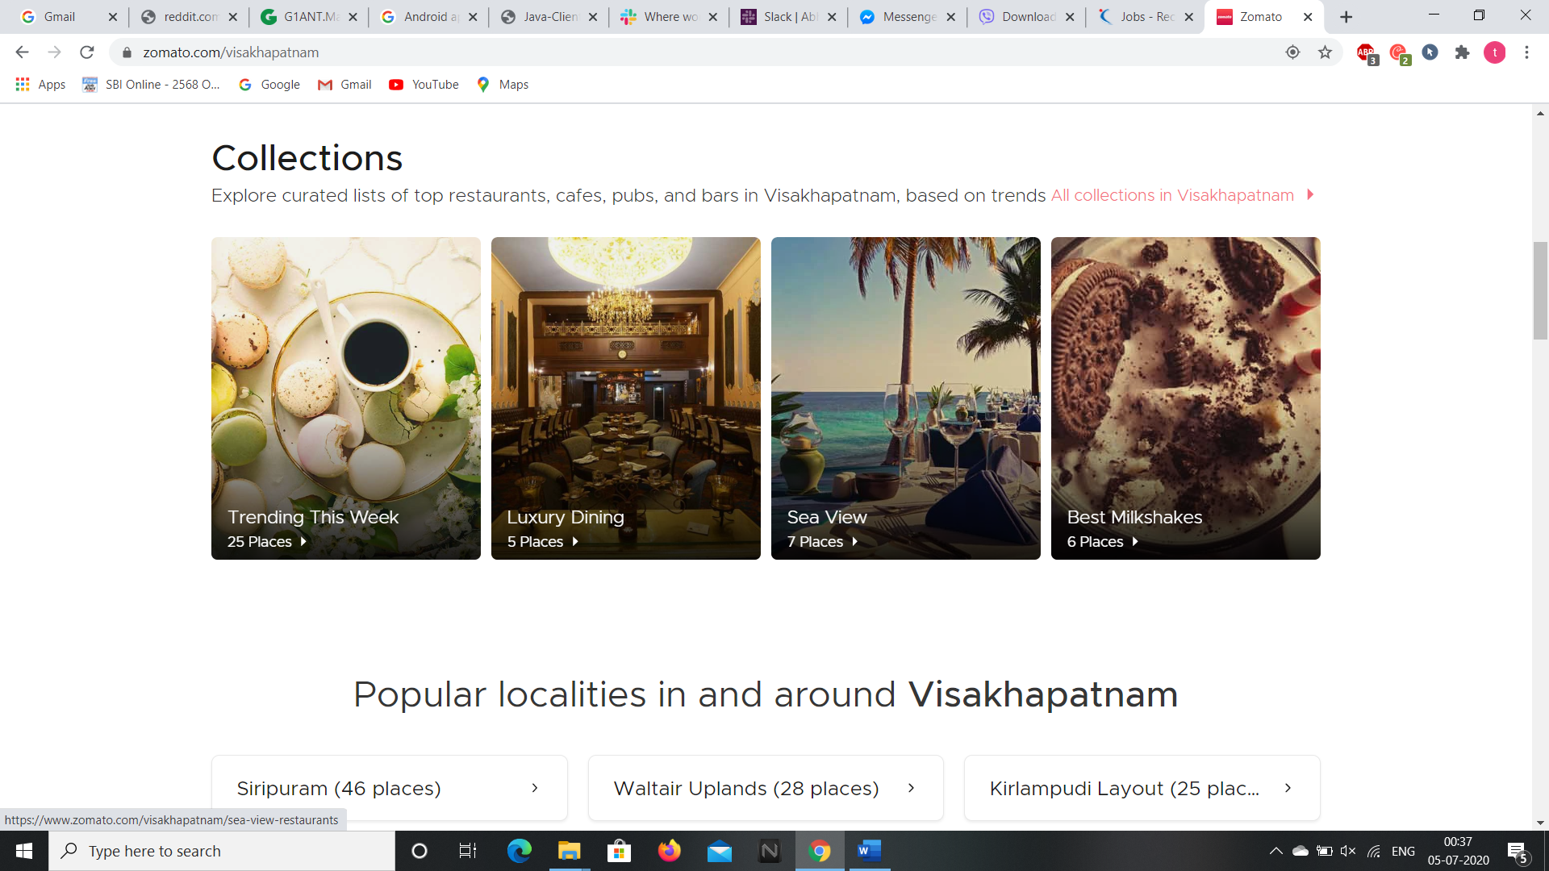

**3.When the search box is clicked the trending food items are shown.**

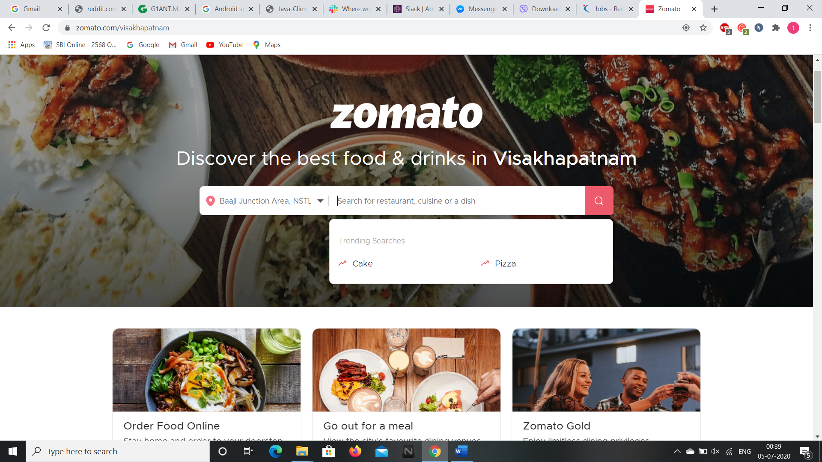

**4.When the required item is searched the restaurants selling the item are shown as well as the price of the item. We can filter the search according to our needs.**

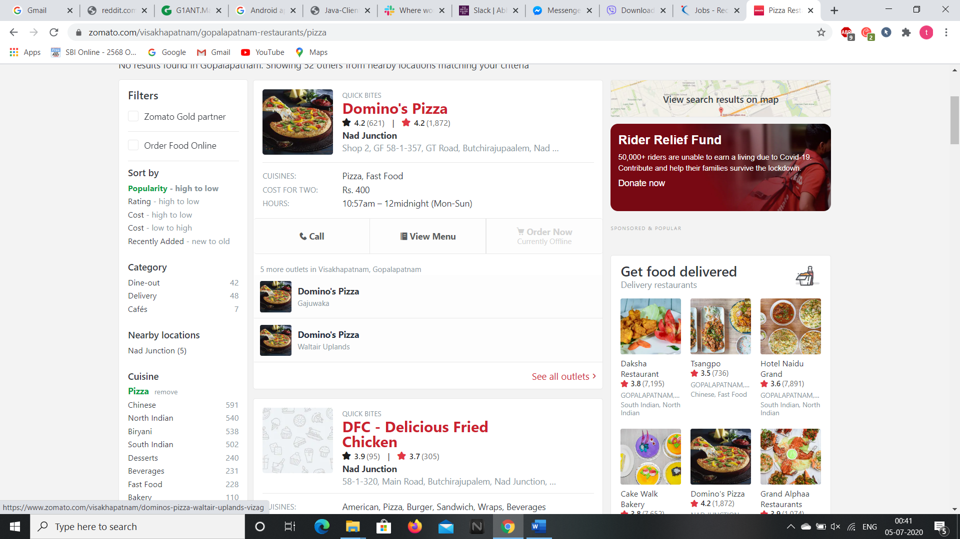

**5.By clicking on the item the details of the item is obtained with the reviews, recommendations, ratings, photos, menu of the items.**

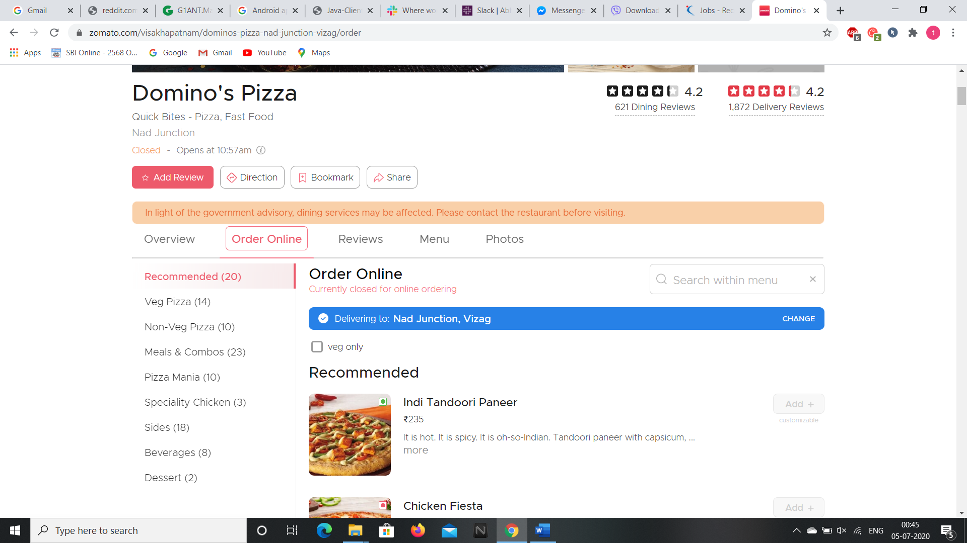

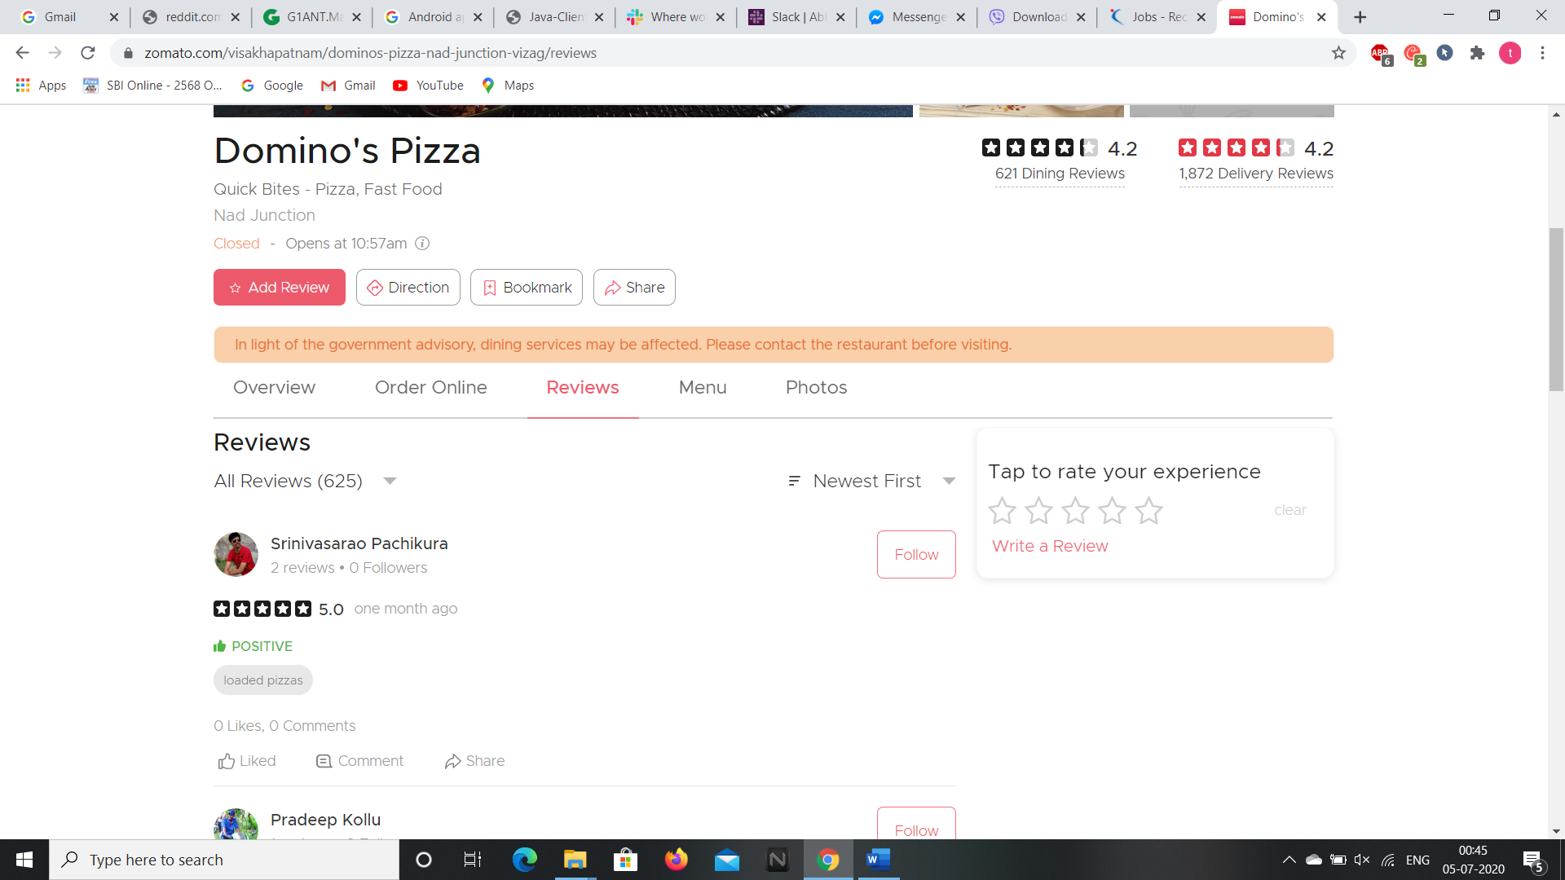

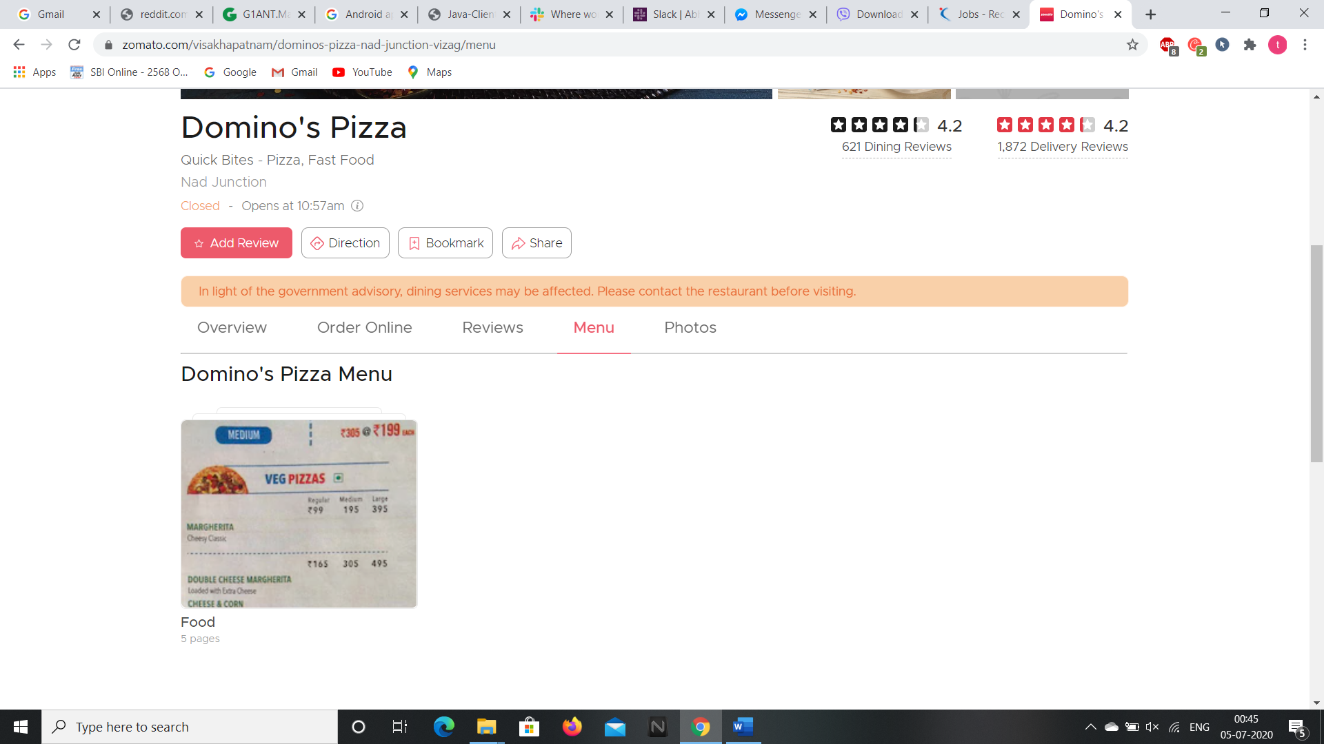

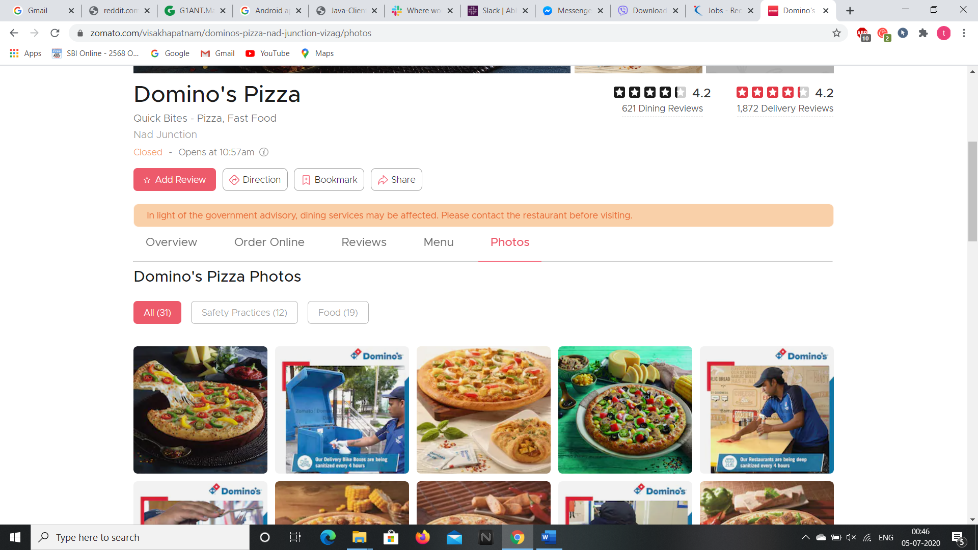

**6.We can also find our friends, network, profile, bookmarks and settings by clicking on the drop down arrow beside our profile(no image due to privacy and secrecy issues).**

**This is the way we can order our favourite dishes through this web application.**

**So this is the way we can access the contents of this web application and we can access the webpage through selenium addon as well. Now, let’s see the android application of it.**

**ANDROID APPLICATION**

**We can download the android application through “Google Play Store” and installing it in the Virtual Phone through Android Studio.**

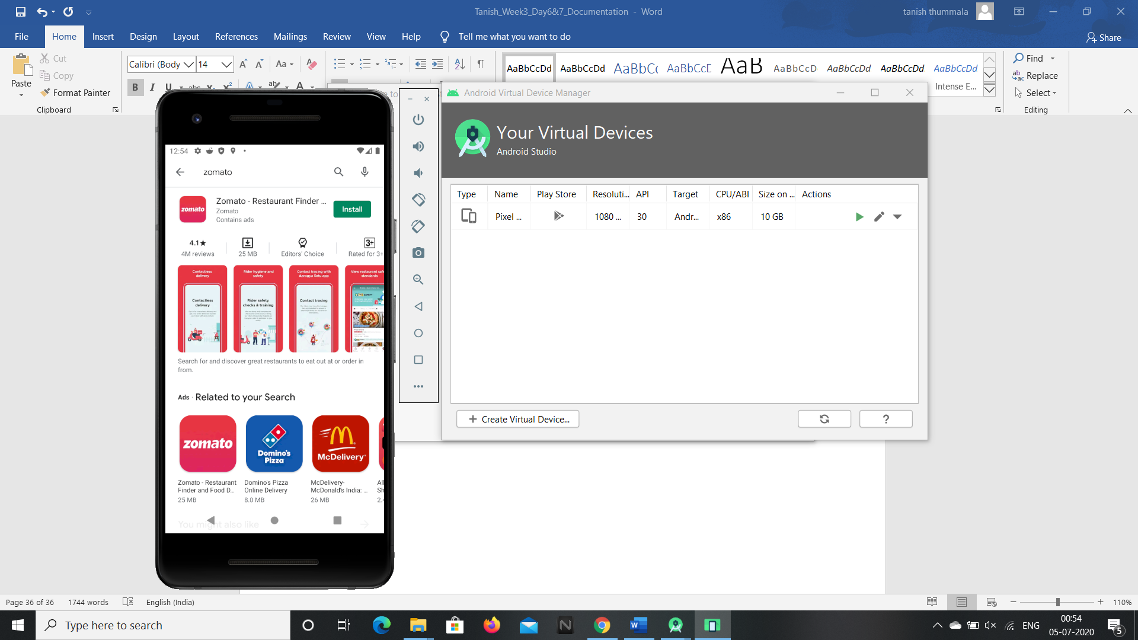

**1.After installing and opening the app, it asks to sign up or login if we have already signed up then login to zomato app.**

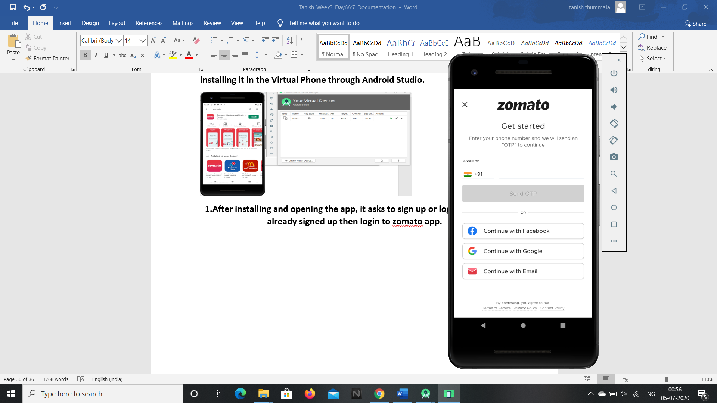

**2.After logging in, the home page is opened with the popular collections and dishes near our area.**

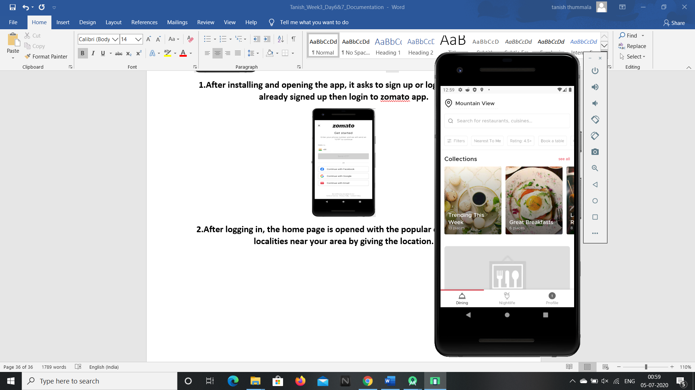

**3.We can give our locality by clicking on the present location dialog box at the top of the screen.**

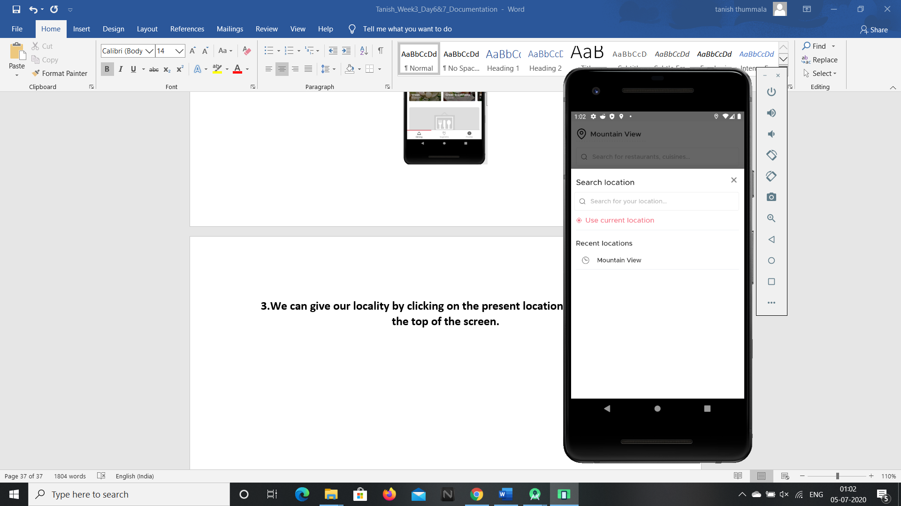

**4.We can search the required dish we want by typing the text in the search box.**

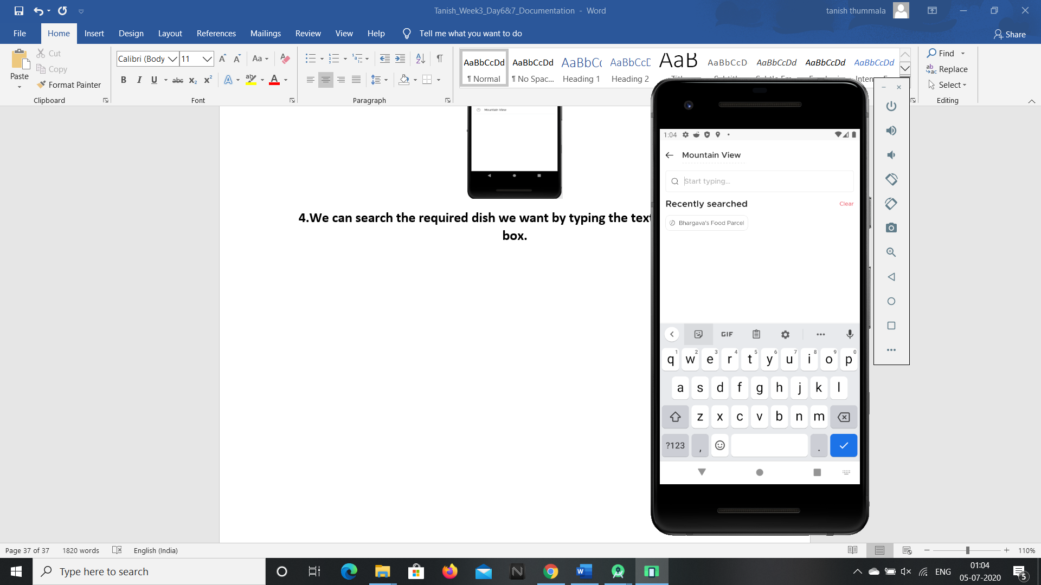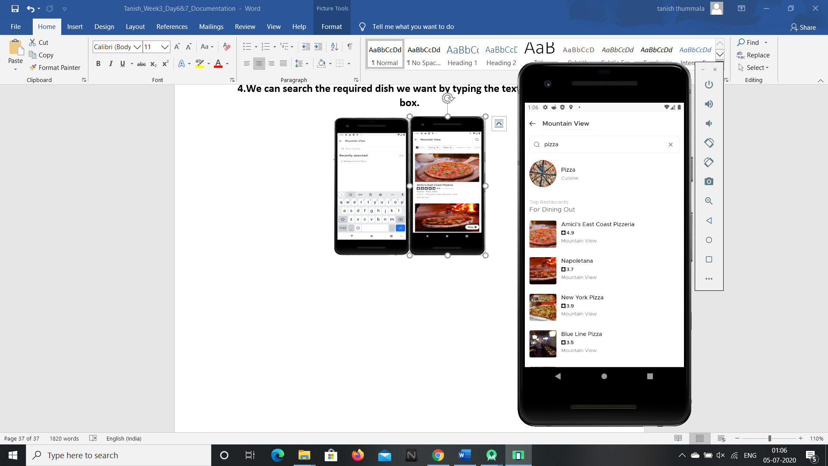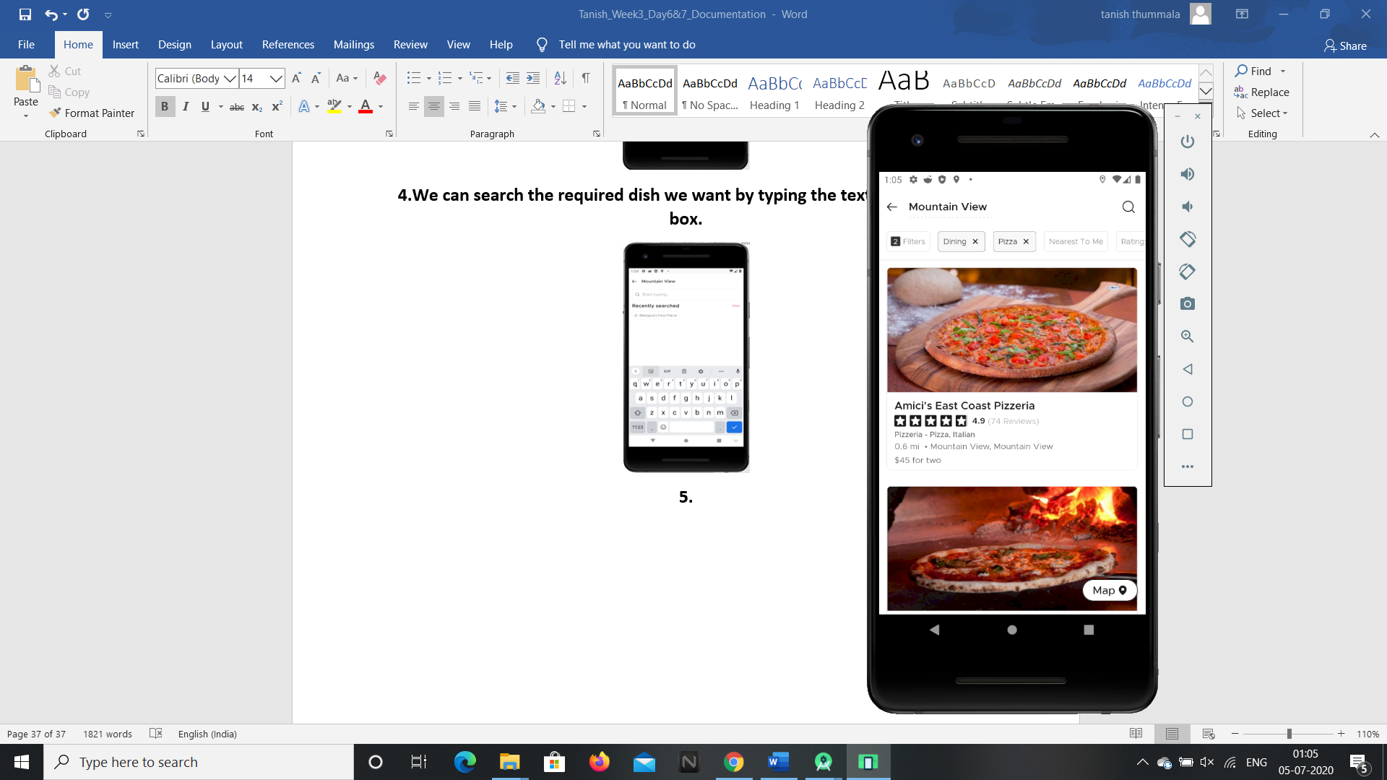

**5.We can view the ratings, reviews, photos and menu of the item.**

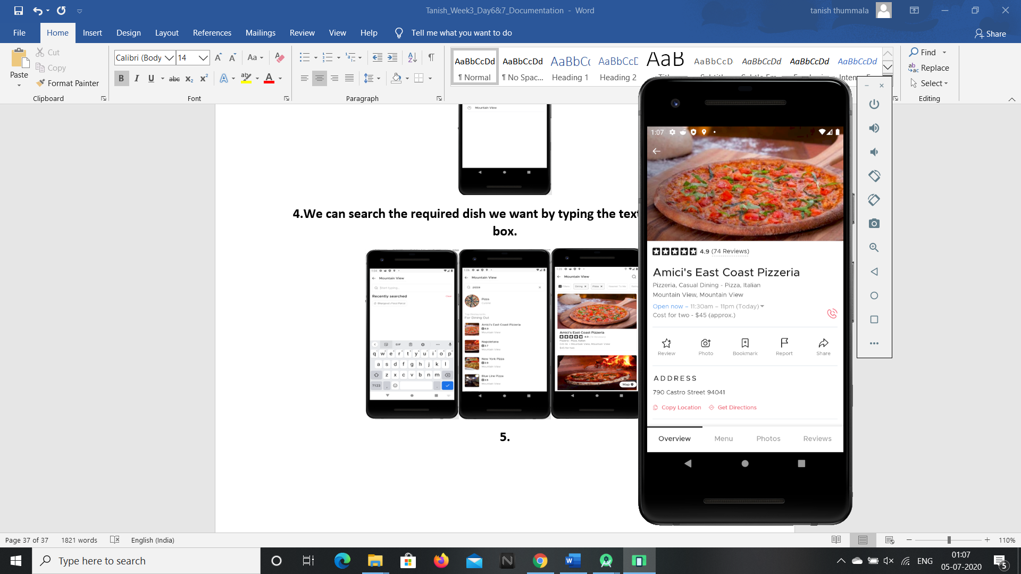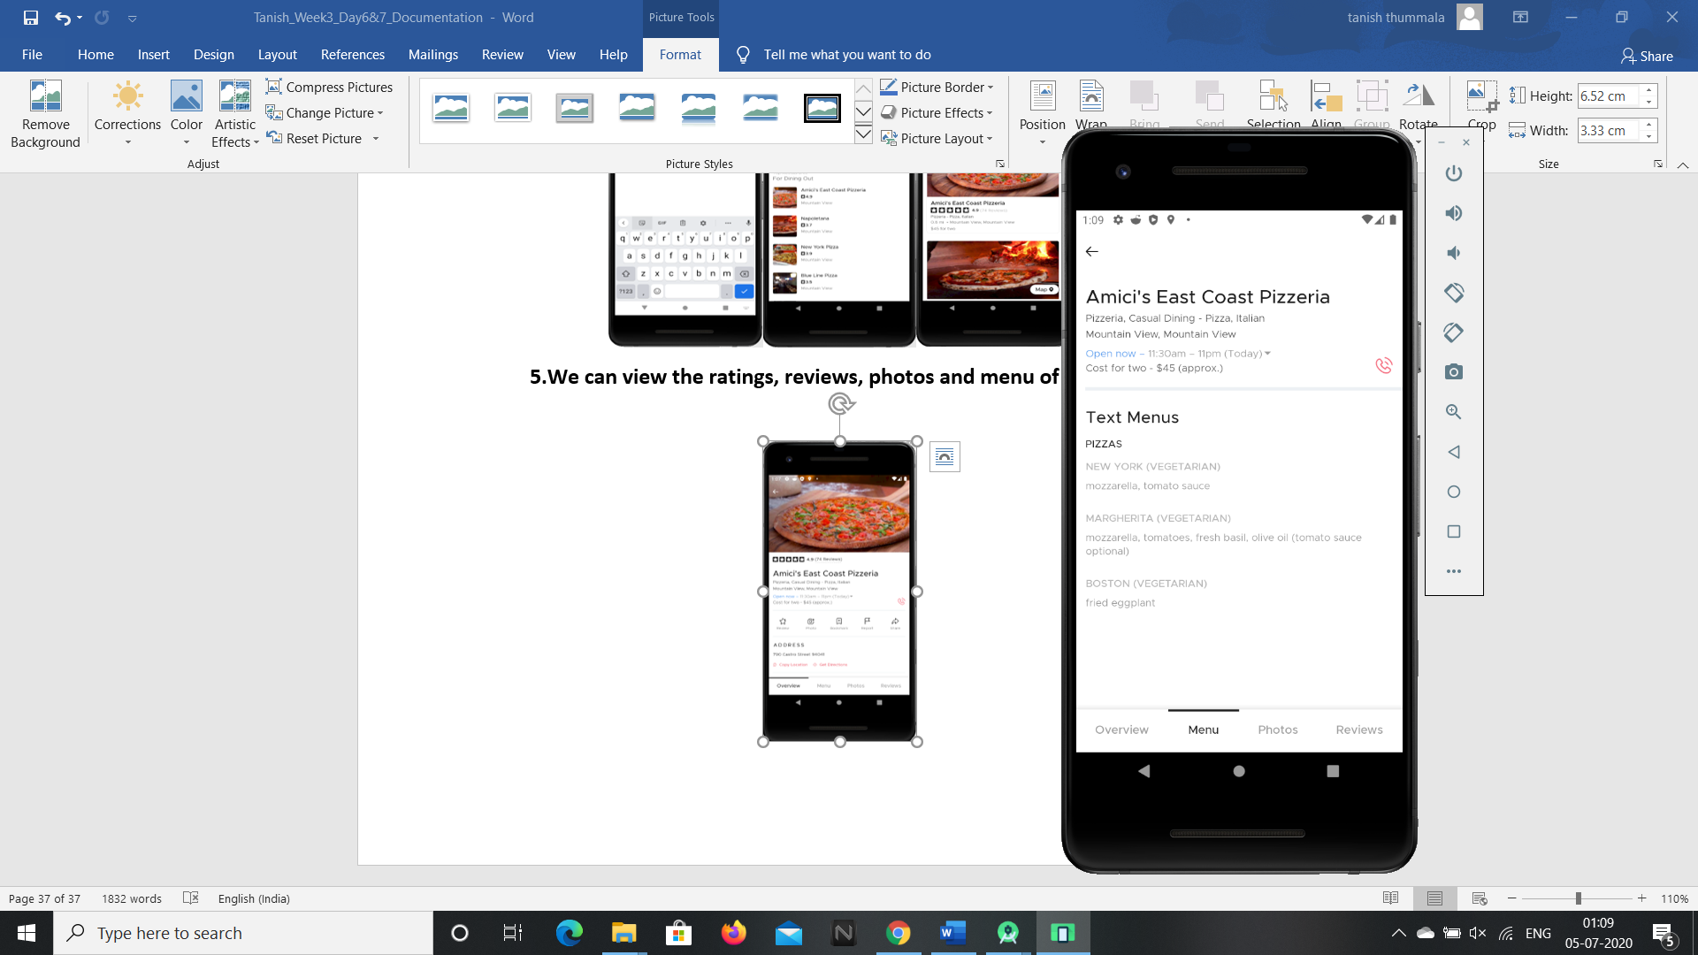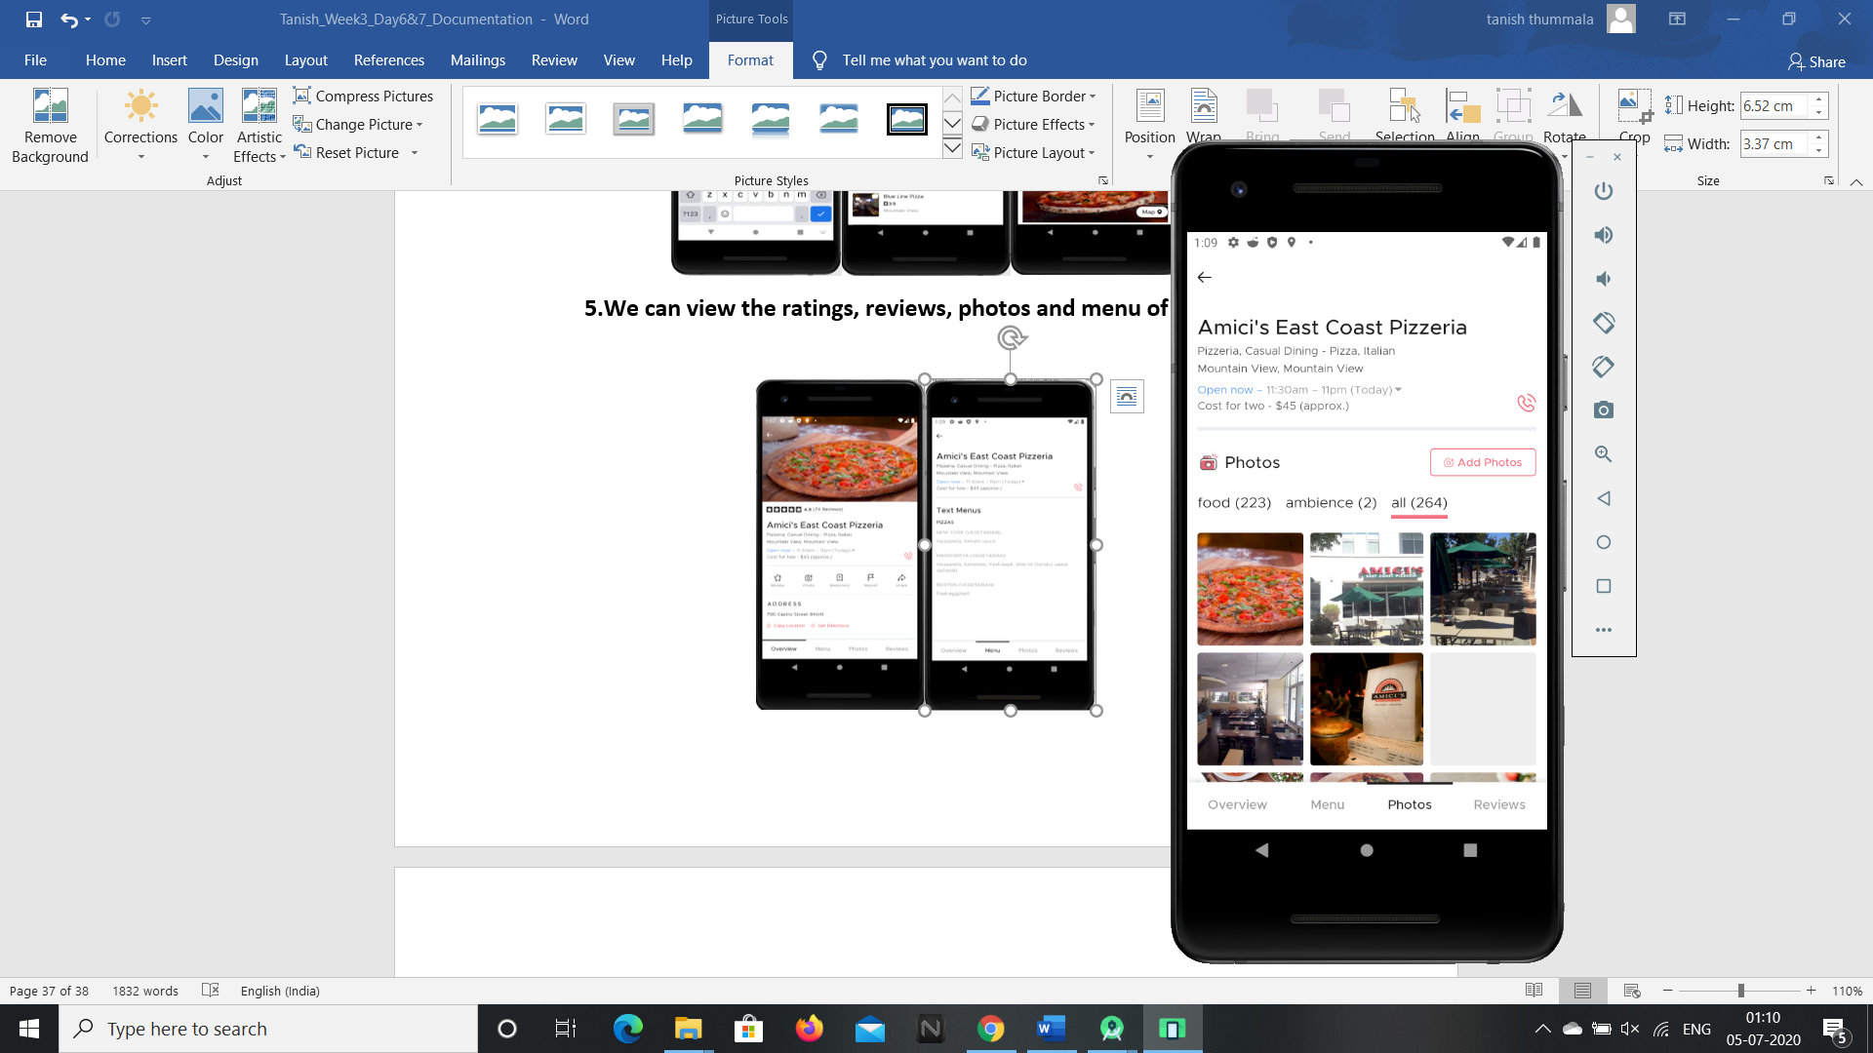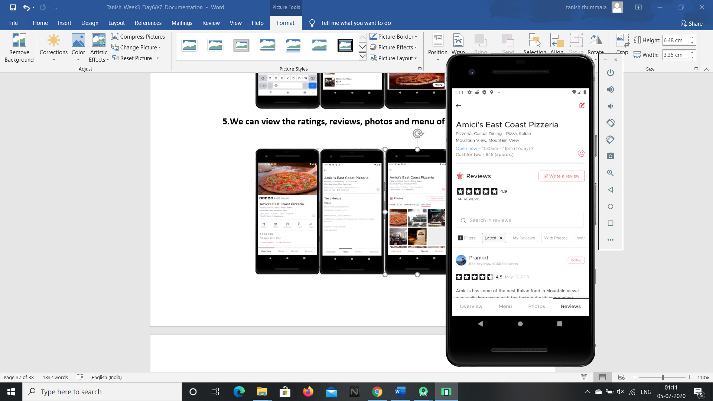

**6.We can also open the option “Nightlife” by clicking the middle icon in the bottom of the screen.**

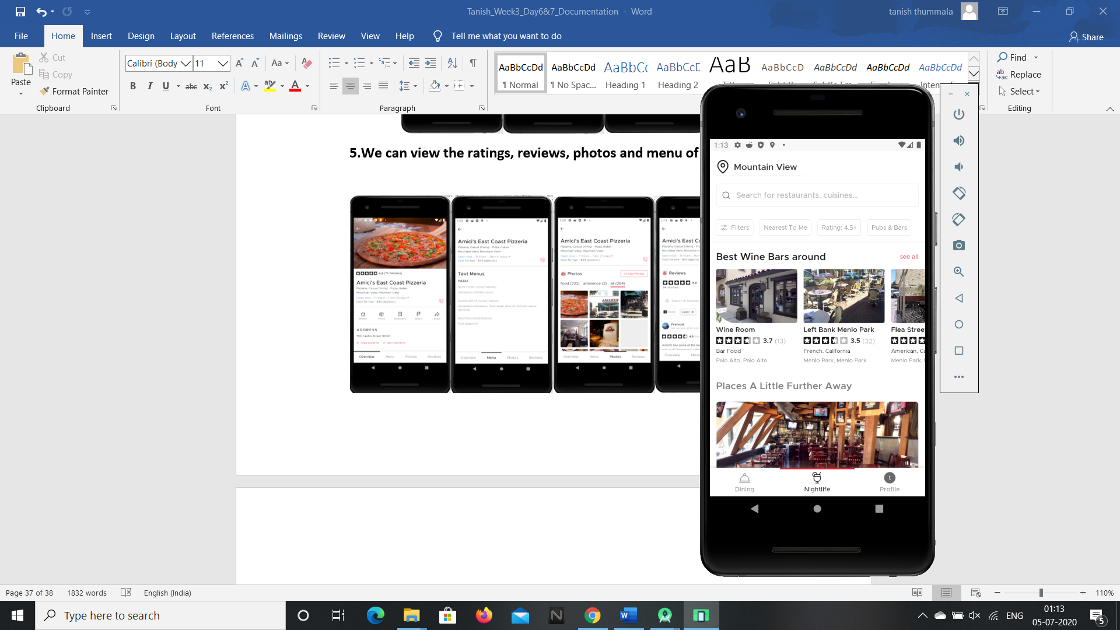

**7.We can also open the profile page by clicking on the profile icon(no image due to secrecy and privacy issues).**

**So these are the features present in the zomato android application and these can be accessed by G1ANT Robot through Appium addon.**